ByteCraft2 User Manual
Version: 2.0
Author: Dr. Eric O. Flores
May 2025
License: Creative Commons Zero (CC0 1.0 Universal)

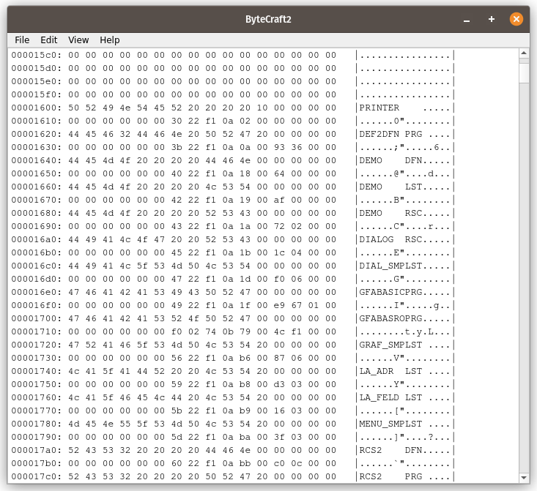
1. Introduction
ByteCraft2 is a lightweight, modular, and powerful hex editor built in Python using the PyQt5 framework. It allows users to open, view, edit, and analyze binary files in both hexadecimal and ASCII formats. ByteCraft2 is a complete redesign and refactoring of the original ByteCraft hex editor, introducing a cleaner architecture, improved testability, and better support for future features.

2. What is ByteCraft2?
ByteCraft2 is a professional-grade application designed for engineers, reverse engineers, data analysts, and software developers who need to interact with raw binary data. It supports split view, hex/ASCII toggling, dark/light mode, search and replace (both ASCII and hex), and printing to PDF.
ByteCraft2 is built with modularity in mind: each major functionality is encapsulated in a separate module. This makes the code base is easier to test, extend, and maintain.

3. Architecture Overview
ByteCraft2 is structured as follows:
bytecraft2/
├── main.py # App launcher
├── ui/
│ ├── main_window.py # GUI logic and layout
│ └── theme_manager.py # Dark/light mode styling
├── core/
│ ├── file_handler.py # File I/O logic
│ ├── hex_formatter.py # Hex + ASCII layout formatting
│ ├── search_engine.py # Search and replace functionality
│ └── highlighter.py # Text and hex highlighting logic
├── tests/ # Pytest-based unit tests
├── resources/ # Stylesheets (QSS)
├── Makefile # CLI commands for run/lint/test/clean
└── pytest.ini # Test configuration
Each module is designed to isolate a specific concern, which allows for focused unit testing and easy refactoring. The main aim was for any programmer to easily expand the hex editors functionality.

4. GitHub Repositories
The original ByteCraft project was released in September 2023 and is available at: https://github.com/drericflores/bytecraft
This current, modularized version—ByteCraft2—is hosted at: https://github.com/drericflores/bytecraft2
Users are encouraged to refer to ByteCraft2 for the latest features, fixes, and contributions.

5. Fixes and Enhancements from ByteCraft 1
Feature | ByteCraft 1 | ByteCraft2
Code structure | Monolithic | Fully modular (core/ui/tests separation)
Search support | Basic | Dual-mode ASCII/hex with validation
Replace support | Inline, no validation | Robust, error-tolerant replace engine
Dark/Light mode | Hardcoded styling | Theme manager module
Split View | Inlined | Toggleable hex/text pane
Printing | Basic | Retained, simplified via PyQt5
Testing | None | Fully tested using Pytest
Automation | None | Makefile: run, test, lint, clean
Linting | None | Flake8-compatible
Imports | Fragile | Robust via pytest.ini

6. Running the Application
To launch ByteCraft2:
make run
To run tests:
make test
To lint the code:
make lint

7. Licensing
ByteCraft2 is released under the Creative Commons Zero (CC0 1.0 Universal) license. This places the software in the public domain to the fullest extent allowed by law.
You are free to:
- Use it for any purpose
- Modify it
- Distribute it
- Build upon it
No attribution required, but credit to Dr. Eric O. Flores is appreciated.
Full license text: https://creativecommons.org/publicdomain/zero/1.0/

8. Credits
- Original concept and development by Dr. Eric O. Flores
- Modularization and test design enhanced with support from AI-assisted engineering tools
- Built with Python 3, PyQt5, pytest, and Flake8

9. Contact
For questions, feedback, or contributions, contact:
Email: eoftoro@gmail.com
Thank you for using ByteCraft2.

